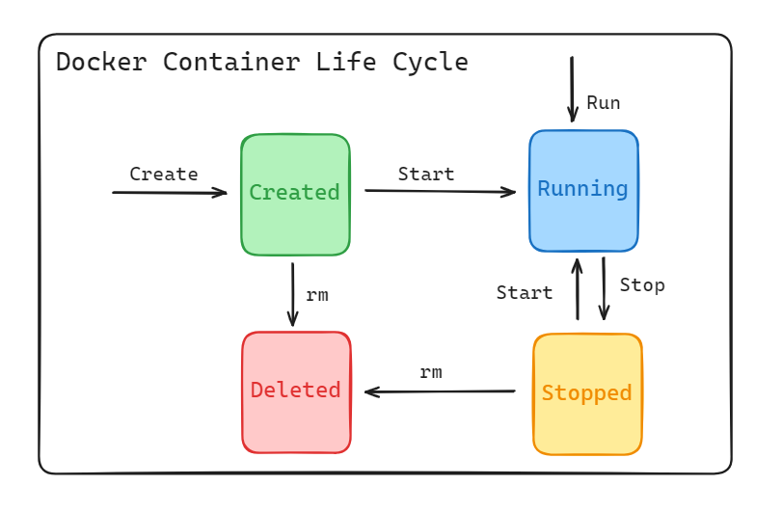**The Lifecycle of a Container**

This document outlines the lifecycle of a Docker container, from creation to deletion, using the example of a container named "percy."

**1. Creating and Starting a Container**

To create and start a Docker container, use the docker run command. This example names the container "percy" and starts an interactive bash shell within an Ubuntu container:

docker run --name percy -it ubuntu:latest /bin/bash

Once the command is executed, we are placed inside the container shell

root@b92ace4338e7:/#

**2. Writing Data to the Container**

Within the container, we can write data to the filesystem. The following commands navigate to the /tmp directory, create a new file, and verify its contents:

cd /tmp

ls -l

Now, create a file named newfile in this directory:

echo "This is the file about container lifecycle" > newfile

ls -l

View the data of the file using:

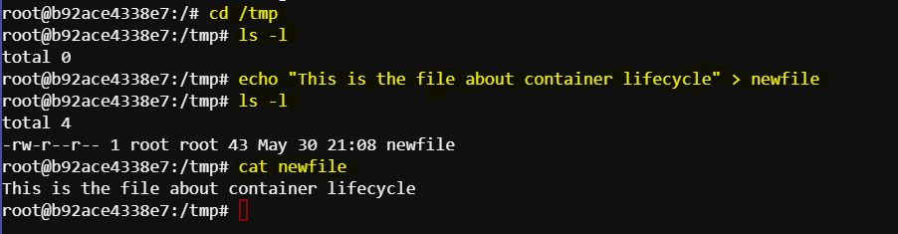cat newfile

**3. Stopping the Container**

Press Ctrl-PQ to exit the container without killing it. To stop the container, use the docker stop command:

docker stop percy

**4. Listing Containers**

To verify the container's status, list all running containers:

docker ps

Since the container is stopped, it won't appear in the list. To show all containers, including stopped ones, use:

docker ps -a

We should see an output similar to this:

CONTAINER ID IMAGE COMMAND CREATED STATUS PORTS NAMES

b92ace4338e7 ubuntu:latest "/bin/bash" 12 minutes ago Exited (137) 26 seconds ago percy

**5. Restarting the Container**

Restart the stopped container with the docker start command:

docker start percy

Check the running containers again:

docker ps

Now, the container should be running again and we should see an output similar to this:

CONTAINER ID IMAGE COMMAND CREATED STATUS PORTS NAMES

b92ace4338e7 ubuntu:latest "/bin/bash" 14 minutes ago Up 4 seconds percy

**6. Verifying Data Persistence**

Reattach to the container to verify the data persistence:

docker exec -it percy bash

Check the file created earlier:

cd /tmp

ls -l

cat newfile

we should see an output similar to this:

This is the file about container lifecycle

This demonstrates that the data persisted even after the container was stopped and restarted.

**7. Deleting the Container**

Press Ctrl-PQ to exit the container without killing it. To delete the container, first stop it if it’s running:

docker stop percy

Then remove the container:

docker rm percy

Verify the container has been deleted:

docker ps -a

No containers should be listed.

**Conclusion**

This document outlined the lifecycle of a Docker container through the example of a container named "percy". We covered how to create, start, stop, restart, and delete a container, as well as how to verify data persistence within the container. By following these steps, we can effectively manage Docker containers and understand their lifecycle.